Student Marks Data Processor
Development Document
Student | Faheem Shehzad
Student ID | 689167
Module | CPUF001 Software Foundation
Assignment | S1 Development Project
Module Leader | Moses Bankole
Deadline | 18 September 2026 at 23:59

GitHub repository
https://github.com/fahem12363/FAHEEM-BSU-STUDENTS-MARKS-PROJECT

1 Introduction and Problem Analysis
This project interprets the brief as a command-line data processing application that reads structured student assessment data from a CSV file, performs calculations and writes useful results to new files. Each input row contains a student ID, a student name and three assessment marks. The program calculates a total and average, then assigns a degree classification and pass or fail outcome. I chose this problem because it demonstrates the required programming concepts through a realistic task that can be tested clearly. The finished solution uses sequence, selection, iteration, functions, file handling, validation and exception handling, while a separate report makes the results easy to review.
The program must receive its input file through the command line, so the design uses argparse to read the CSV filename rather than requesting interactive input. CSV was selected because it can be created in a text editor or spreadsheet and uses named columns. The required headings are student_id, student_name, assessment1, assessment2 and assessment3. The program confirms that these headings exist and checks that every mark is numeric and falls between 0 and 100. Rows containing invalid values are skipped and recorded as warnings, allowing the remaining valid records to be processed safely. A completely missing file, incorrect header or file with no valid records produces a clear error and exit code 1.
For every valid student, the first calculation adds the three marks to produce a total out of 300. The second divides that total by three to produce an average percentage. Selection logic then converts the average into First, 2:1, 2:2, Third or Fail, while 40 is used as the pass threshold. The processed rows are written to processed_results.csv. The program also calculates the class average, pass and fail counts, and the highest and lowest student averages for processing_report.txt. These features exceed the minimum two-calculation requirement and provide evidence of useful data transformation.

2 Solution Design
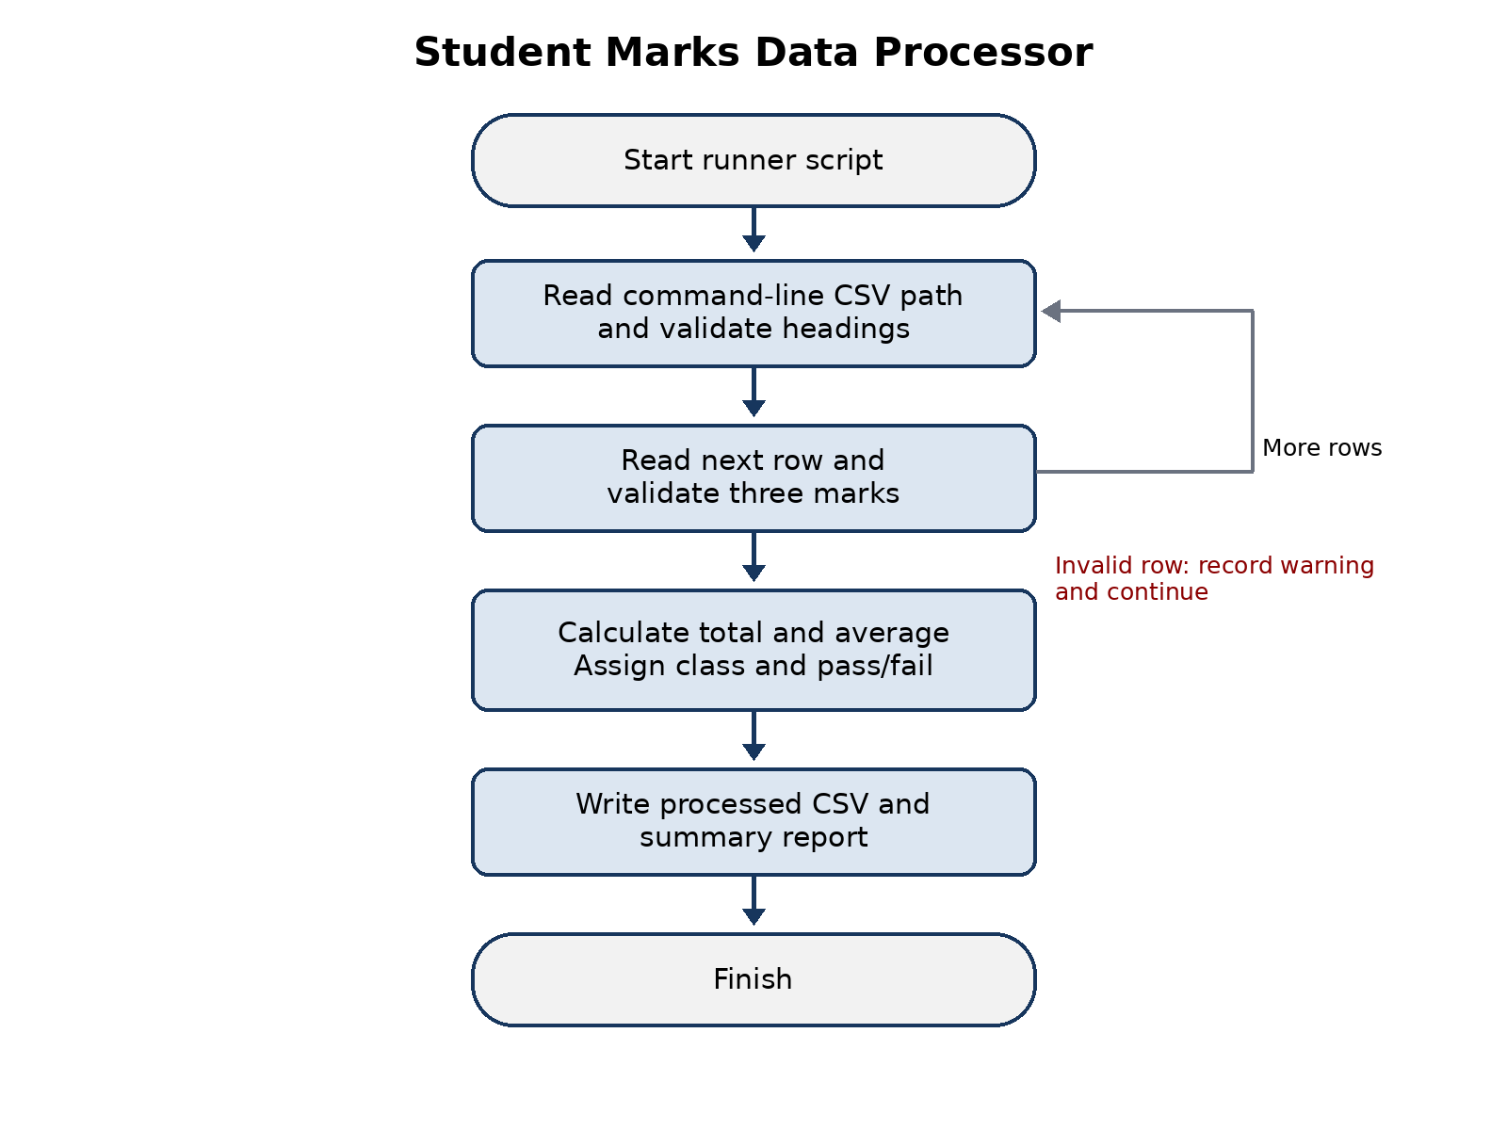
Figure 1 Program flow from command-line input to generated outputs
The runner script starts the Python program and passes input_data.csv as the command-line argument. parse_arguments reads this value and optional output names. main converts the input to an absolute path and creates output paths in the same directory. It coordinates each stage inside a try and except structure. Expected file, permission and validation problems are displayed in plain language; success returns exit code 0 and failure returns 1. Both a Windows batch file and a macOS or Linux shell script are provided, demonstrating that the program can be started from accepted command-line environments.
process_file opens the CSV with a context manager, which closes the file automatically. csv.DictReader accesses values by column name. A set comparison identifies missing headings before any rows are processed. A for loop then iterates through the data, beginning at line two because line one contains the header. Blank rows are ignored. validate_mark converts each mark to a floating-point number and rejects values outside the permitted range. If one row is invalid, its message is added to a warning list and the loop continues, which is more useful than losing every correct result because of one mistake.
For a valid row, sum calculates the total and division calculates the average. classification_from_average uses an if structure ordered from the highest boundary to the lowest. The program stores each completed result as a dictionary in a list. write_output uses csv.DictWriter to preserve the original fields and append total, average, classification and result. write_report converts the saved averages back to numbers, uses statistics.mean for the class average, generator logic for the pass count, and max and min with key functions to locate the highest and lowest performers. Output values use consistent decimal formatting.

3 Testing
Test | Action | Expected result | Outcome
Normal data | Run input_data.csv | 8 valid rows and two output files | Pass
Missing file | Use an absent filename | Clear error and safe exit | Pass
Invalid mark | Use 110 or text | Row skipped and warning recorded | Pass
Missing column | Remove assessment3 | Missing-column error displayed | Pass
Boundary | Average equals 40 | Third classification and Pass | Pass
The supplied data covers high, middle and failing outcomes. Two automated unit tests also verify every classification boundary and confirm that an invalid row is skipped while a valid row is retained. The final sample run processed eight valid records, created both output files and completed with no errors.

4 Reflective Evaluation
The most interesting part of this project was seeing how a basic CSV file could become information that is easier to interpret. Initially, I considered the task mainly as two calculations, but I learned that validation, structure and clear feedback are equally important. Separating the work into functions helped me understand and test the program because each function has one main purpose. I also learned why exception handling matters. Without it, one missing file or incorrect mark could stop the program with a technical traceback that would not help the user.
The strongest aspect is that the solution meets the minimum requirements while adding useful features: multiple classifications, row-level validation, summary statistics, cross-platform runner scripts and automated tests. It is reusable because a different CSV file can be supplied without changing the source code. The output CSV provides detailed evidence, while the text report gives a fast overview of the class.
There are still improvements I would make. A later version could detect any number of assessment columns, support weighted marks, allow a chosen output directory and write a formal log. A graphical interface might make the program easier for non-technical users, although it would not replace the command-line version required by the brief. More automated tests could cover file permissions and unusual text encodings. I would like to develop my knowledge of object-oriented programming, testing frameworks and application packaging. Overall, this project strengthened my understanding of sequence, selection, iteration, functions, CSV processing and defensive programming. The flowchart also showed me how planning the logic before coding can reduce mistakes.

5 Running the Project
- Place student_data_processor.py, run_project.bat or run_project.sh, and input_data.csv in one folder.
- On Windows, open Command Prompt in the folder and run run_project.bat.
- On macOS or Linux, run chmod +x run_project.sh and then ./run_project.sh.
- Alternatively run python student_data_processor.py input_data.csv.
- Check processed_results.csv and processing_report.txt after execution.
- Upload the source files to the assignment GitHub repository and check that the repository link on the cover page points to the uploaded code.

Appendix A Python Source Code
#!/usr/bin/env python3
"""Process student assessment marks supplied in a CSV file.
Usage:
python student_data_processor.py input_data.csv
"""
import argparse
import csv
import os
import sys
from statistics import mean
REQUIRED_FIELDS = {
"student_id",
"student_name",
"assessment1",
"assessment2",
"assessment3",
}
def validate_mark(value, field_name, line_number):
"""Convert a mark to float and ensure it is in the range 0 to 100."""
try:
mark = float(value)
except (TypeError, ValueError) as exc:
raise ValueError(
f"Line {line_number}: {field_name} must be a number; received {value!r}."
) from exc
if not 0 <= mark <= 100:
raise ValueError(
f"Line {line_number}: {field_name} must be between 0 and 100; "
f"received {mark}."
)
return mark
def classification_from_average(average):
"""Return a UK-style degree classification for an average mark."""
if average >= 70:
return "First"
if average >= 60:
return "2:1"
if average >= 50:
return "2:2"
if average >= 40:
return "Third"
return "Fail"
def process_file(input_path):
"""Read, validate and transform student records from a CSV file."""
processed_rows = []
warnings = []
with open(input_path, "r", newline="", encoding="utf-8-sig") as input_file:
reader = csv.DictReader(input_file)
if reader.fieldnames is None:
raise ValueError("The input file does not contain a header row.")
missing_fields = REQUIRED_FIELDS.difference(reader.fieldnames)
if missing_fields:
raise ValueError(
"Missing required column(s): " + ", ".join(sorted(missing_fields))
)
for line_number, row in enumerate(reader, start=2):
if not any((value or "").strip() for value in row.values()):
continue
try:
student_id = (row["student_id"] or "").strip()
student_name = (row["student_name"] or "").strip()
if not student_id or not student_name:
raise ValueError(
f"Line {line_number}: student_id and student_name are required."
)
marks = [
validate_mark(row[field], field, line_number)
for field in ("assessment1", "assessment2", "assessment3")
]
except ValueError as error:
warnings.append(str(error))
continue
total = sum(marks)
average = total / len(marks)
classification = classification_from_average(average)
processed_rows.append(
{
"student_id": student_id,
"student_name": student_name,
"assessment1": f"{marks[0]:.1f}",
"assessment2": f"{marks[1]:.1f}",
"assessment3": f"{marks[2]:.1f}",
"total": f"{total:.1f}",
"average": f"{average:.2f}",
"classification": classification,
"result": "Pass" if average >= 40 else "Fail",
}
)
if not processed_rows:
raise ValueError("No valid student records were found in the input file.")
return processed_rows, warnings
def write_output(processed_rows, output_path):
"""Write detailed calculated results to a new CSV file."""
fieldnames = [
"student_id",
"student_name",
"assessment1",
"assessment2",
"assessment3",
"total",
"average",
"classification",
"result",
]
with open(output_path, "w", newline="", encoding="utf-8") as output_file:
writer = csv.DictWriter(output_file, fieldnames=fieldnames)
writer.writeheader()
writer.writerows(processed_rows)
def write_report(processed_rows, warnings, report_path, input_path, output_path):
"""Create a readable summary of the processing activity and class results."""
averages = [float(row["average"]) for row in processed_rows]
pass_count = sum(row["result"] == "Pass" for row in processed_rows)
top_student = max(processed_rows, key=lambda row: float(row["average"]))
lowest_student = min(processed_rows, key=lambda row: float(row["average"]))
with open(report_path, "w", encoding="utf-8") as report:
report.write("STUDENT MARKS DATA PROCESSING REPORT\n")
report.write("=" * 36 + "\n")
report.write(f"Input file: {os.path.basename(input_path)}\n")
report.write(f"Output file: {os.path.basename(output_path)}\n")
report.write(f"Valid records processed: {len(processed_rows)}\n")
report.write(f"Invalid records skipped: {len(warnings)}\n")
report.write(f"Overall class average: {mean(averages):.2f}\n")
report.write(f"Passed: {pass_count}\n")
report.write(f"Failed: {len(processed_rows) - pass_count}\n")
report.write(
f"Highest average: {top_student['student_name']} "
f"({top_student['average']})\n"
)
report.write(
f"Lowest average: {lowest_student['student_name']} "
f"({lowest_student['average']})\n"
)
if warnings:
report.write("\nVALIDATION WARNINGS\n")
report.write("-" * 19 + "\n")
for warning in warnings:
report.write(f"- {warning}\n")
def parse_arguments():
"""Read the input filename and optional output paths from the command line."""
parser = argparse.ArgumentParser(description=__doc__)
parser.add_argument("input_file", help="CSV file containing student marks")
parser.add_argument("--output", default="processed_results.csv")
parser.add_argument("--report", default="processing_report.txt")
return parser.parse_args()
def main():
"""Coordinate input, processing and output; return a command-line exit code."""
args = parse_arguments()
input_path = os.path.abspath(args.input_file)
input_directory = os.path.dirname(input_path)
output_path = os.path.join(input_directory, args.output)
report_path = os.path.join(input_directory, args.report)
try:
processed_rows, warnings = process_file(input_path)
write_output(processed_rows, output_path)
write_report(processed_rows, warnings, report_path, input_path, output_path)
except (FileNotFoundError, PermissionError, ValueError, OSError) as error:
print(f"Error: {error}", file=sys.stderr)
return 1
print(f"Processed {len(processed_rows)} valid student record(s).")
print(f"Results written to: {output_path}")
print(f"Report written to: {report_path}")
if warnings:
print(f"Warning: {len(warnings)} invalid row(s) were skipped.")
return 0
if __name__ == "__main__":
raise SystemExit(main())

Appendix B Command Line Scripts

Windows batch script
@echo off
REM CPUF001 Student Marks Data Processor Windows runner.
REM The input CSV filename is passed to the Python program as an argument.
python student_data_processor.py input_data.csv
pause

macOS and Linux shell script
#!/usr/bin/env bash
# CPUF001 Student Marks Data Processor macOS and Linux runner.
# The input CSV filename is passed to the Python program as an argument.
set -eu
python3 student_data_processor.py input_data.csv

Appendix C Sample Input Data
student_id,student_name,assessment1,assessment2,assessment3
S001,Aisha Khan,72,68,75
S002,Daniel Smith,55,61,58
S003,Hamza Ali,39,42,36
S004,Sophie Brown,81,76,84
S005,Noah Williams,46,51,49
S006,Maryam Ahmed,64,67,70
S007,Jack Taylor,28,35,31
S008,Zara Hussain,58,54,62

